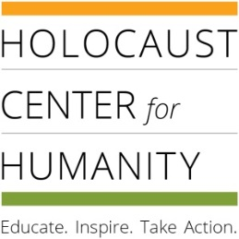
Holocaust Writing, Art, & Film Contest 2017
SUBMISSION FORM

A submission form is required for each entry.
Submit entries February 1 – May 1, 2017
TO ENTER (CHOOSE ONE):
- EMAIL
  - Writing & Art: Email a Word doc, docx, PDF, jpg, or tiff file with this completed submission form to ilana@HolocaustCenterSeattle.org. Subject line: Writing/Art Contest Entry.
  - Film Entries: Post your film online and email the link, or email the media file with your submission form to ilana@HolocaustCenterSeattle.org.
- MAIL - Mail your entry with this completed submission form to: Holocaust Center for Humanity, Attn: Writing, Art, Film Contest, 2045 2nd Avenue, Seattle, WA 98121.
- DELIVER - Schedule a time to drop off the entry with this completed submission form by emailing Ashton@HolocaustCenterSeattle.org or call 206-582-3000.
STUDENTS’ NAME:
STUDENT’S EMAIL:
STUDENT’S PHONE NUMBER:
STUDENT’S ADDRESS:
GRADE:
SCHOOL NAME:
SCHOOL ADDRESS (city/state/zip):
TEACHER’S NAME:
TEACHER’S EMAIL ADDRESS:
AGREEMENT:
I have read and understand the rules and regulations of this contest and I understand that the Holocaust Center will not return my entry (unless I include a stamped and self-addressed envelope). I also understand that the Holocaust Center reserves the right to produce, publish, or exhibit any entry.

Student Signature (or type your name): _________________________________________

